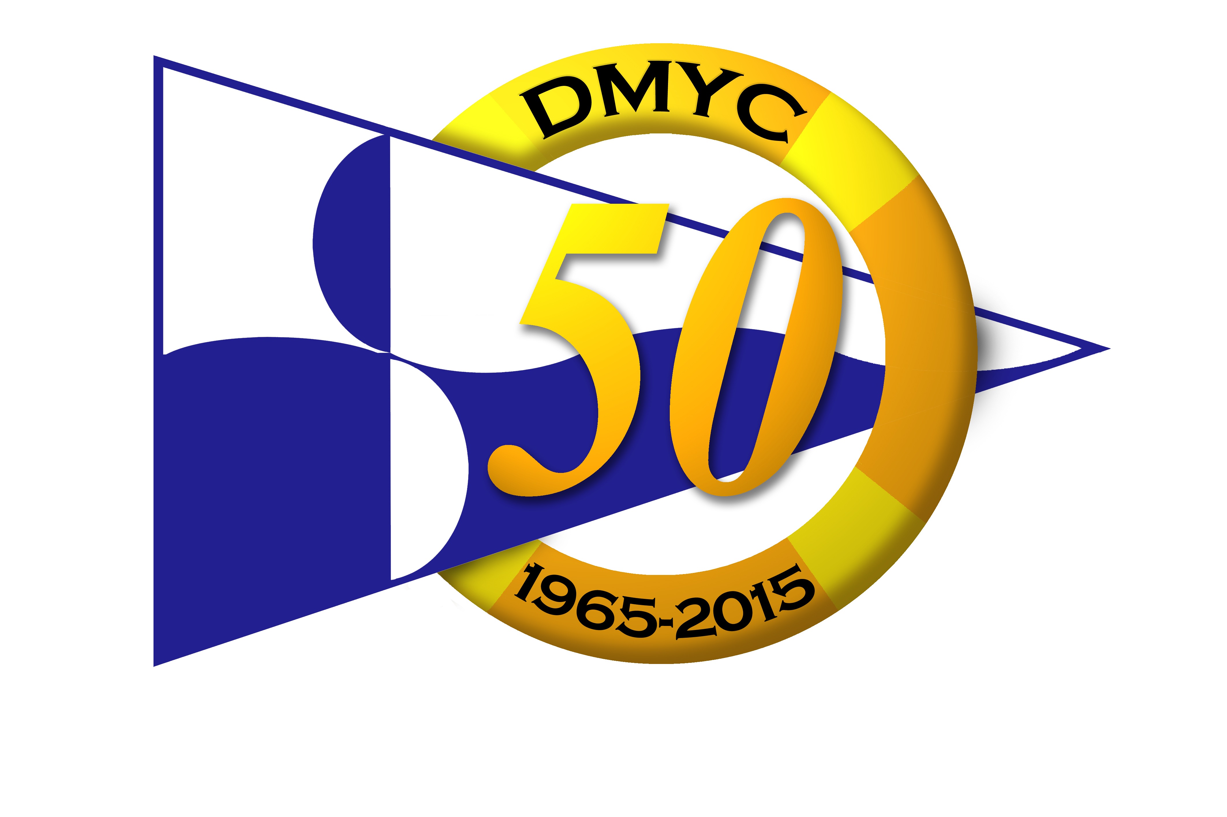
DUN LAOGHAIRE MOTOR YACHT CLUB
West Pier, Dun Laoghaire, Co. Dublin. Tel: 2801371 office@dmyc.ie

September Series, Five races, 2015.
Sundays Sept. 6, 13, 20, 27, & Oct. 4
Incorporating a separate Kish Race 27th Sept.

NOTICE OF RACE

1. Rules and Eligibility
  - Races will be sailed under the Racing Rules of Sailing (RRS), the prescriptions of the Irish Sailing Association (ISA), the rules of each class concerned and this Notice of Race except as modified by the Sailing Instructions and any amendments thereto.

- 2. Classes
  - Races will be provided for the following classes: Cruiser 0, Cruiser 1, Cruiser 2, Cruiser 3, White Sail Cruiser, Sigma 33, Ruffian 23, Shipman, Beneteau 21, (Beneteau 31.7 will race with Cruiser 2; Separate results may be provided depending on numbers). Classes will be based on ECHO STANDARDS. (Subject to the organizing committee’s right to allocate a boat to any Class).

- 3. Schedule of Races.

- Hut Starts: September Sundays 6th, 13th, 20th & Oct 4th around DBSC marks, warning gun 10.25.

- Committee Boat Starts: Sun 27th incorporates a Kish race, warning gun 10.25.

4. Entries
Entry fees: One design €50, ECHO €50, ECHO & IRC €60.

A copy of a current IRC handicap certificate must accompany entries where relevant. The closing date for Entries will be Thursday 3rd September at 22.00 hours & Kish Race (only) 24th September at 21:00 (Late entries may be accepted at the discretion of the Race Committee). Cheques payable to: Dun Laoghaire Motor Yacht Club. Debit/Credit cards accepted at the bar.

Separate Kish Race only entry fee: One design €15, ECHO €15, ECHO & IRC €20

- 5. Handicaps
The Following Handicap Criteria will be used in this series: i) IRC TCF value of current certificate; ii) Current DBSC ECHO.

- 6. Sailing Instructions
Sailing Instructions will be published on the DMYC web site and available in the club.

- 7. Social
7.1 Bar menu will be available after each race in the DMYC.
7.2 A full Social Programme and Prize Giving will take place after the last race on Sunday 4th October.

