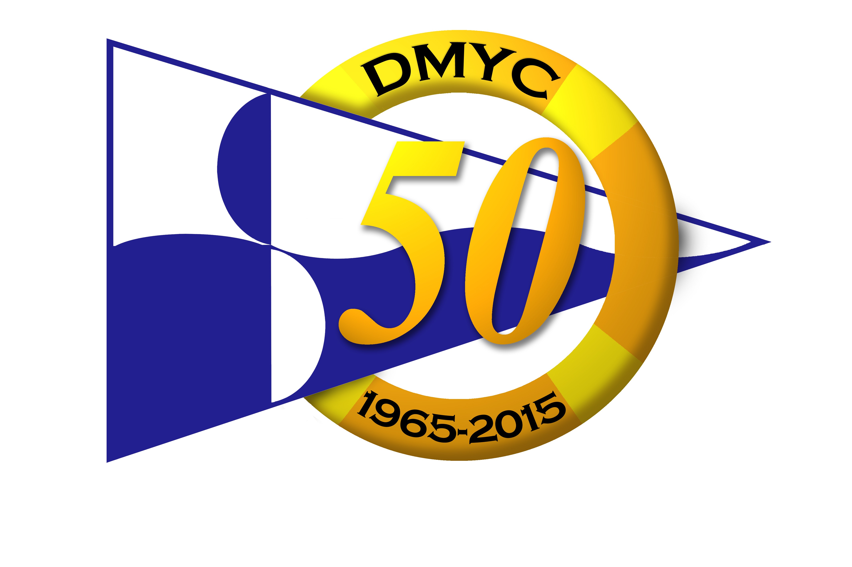

DMYC SEPTEMBER SERIES 2015
Sundays Sept. 6, 13, 20, 27, & Oct.4
ENTRY FORM
BOAT DETAILS (Block Letters Please)
Name of Boat ______________________________Class______________ Type/ Design _______________
Sail No _____________________ Hull Colour________________ ECHO Handicap _______________
IRC 2015 Handicap _____________ (A copy of the current IRC 2015 Certificate must accompany this entry form)
OWNER/ SKIPPER (Block Letters Please)
Name (s) ________________________________________________________________________________
Address _________________________________________________________________________________
Telephone: Work _________________ Home ________________ Mobile ___________________
E Mail ___________________________________________________ Club __________________________
PAYMENT
Entry deadline: September Series 22.00 Thursday, 3rd September, 2015. Kish Race only: 21.00 Thursday, 24th September, 2015.
I enclose my payment (cheques payable to DMYC or by Credit/Debit card in the office/bar. Payments can be made online by visiting dmyc.ie) made up as follows:
One Design: €50 – Kish Race Only, €15 | €__________________________
ECHO: €50 – Kish Race Only, €15 | €__________________________
ECHO & IRC: €60 – Kish Race Only: €20 | €__________________________
Late Entry Fee: €15 (if applicable) | €__________________________
Total Payment h/w | €__________________________
DECLARATION: I wish to enter this boat in the September Series/Kish Race and I agree to be bound by the RRS Rules, the Prescriptions of the ISA, the Class Rules (where applicable), the Notice of Race and the Sailing Instructions. I accept that the participation of the boat in the Series/Kish Race is at my sole and exclusive risk in every respect. By this entry I indemnify the DMYC, its trustees, officers, members, servants, agents and sponsors in respect of all claims and demands in connection with the participation or intended participation of the boat in the Series/Kish Race, and I acknowledge that the DMYC, its trustees, officers, members, servants, agents and sponsors accept no responsibility in respect of loss of life, personal injury or loss or damage to persons or to property that I or any other person may sustain by reason of the participation or intended participation of the boat in the Series/Kish Race. I confirm that I carry adequate valid insurance for Third Party liability of not less than €1,500,000 to cover my liability and my crew’s liability in connection with our participation in the DMYC September Series 2015/ Kish Race.
Signed________________________________________ DATE ____________________

